System Overview

QC Audit Tool

## Summary

QC Audit Tool is used to audit modification options of workout and loss mitigationn deals, including Trial Modifications, HAFA, UP.

## Overview

**System diagram:**



**Major DB diagram:**

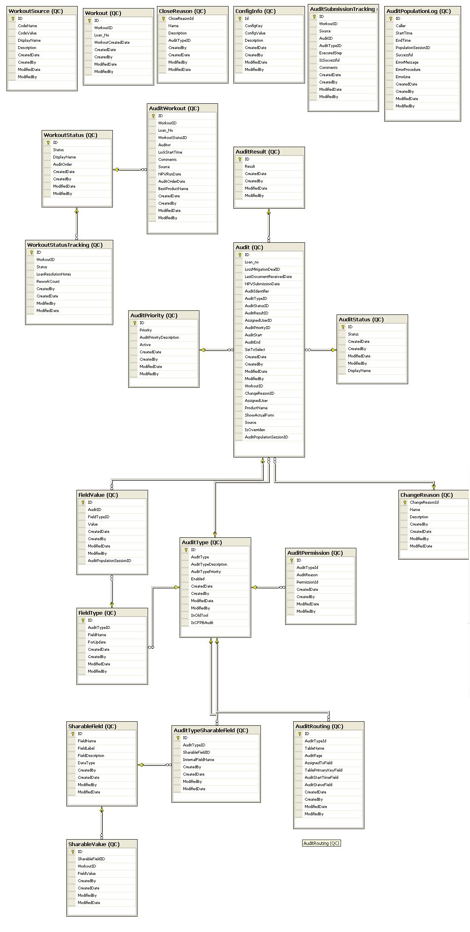

**Below are the class diagrams of the system:**

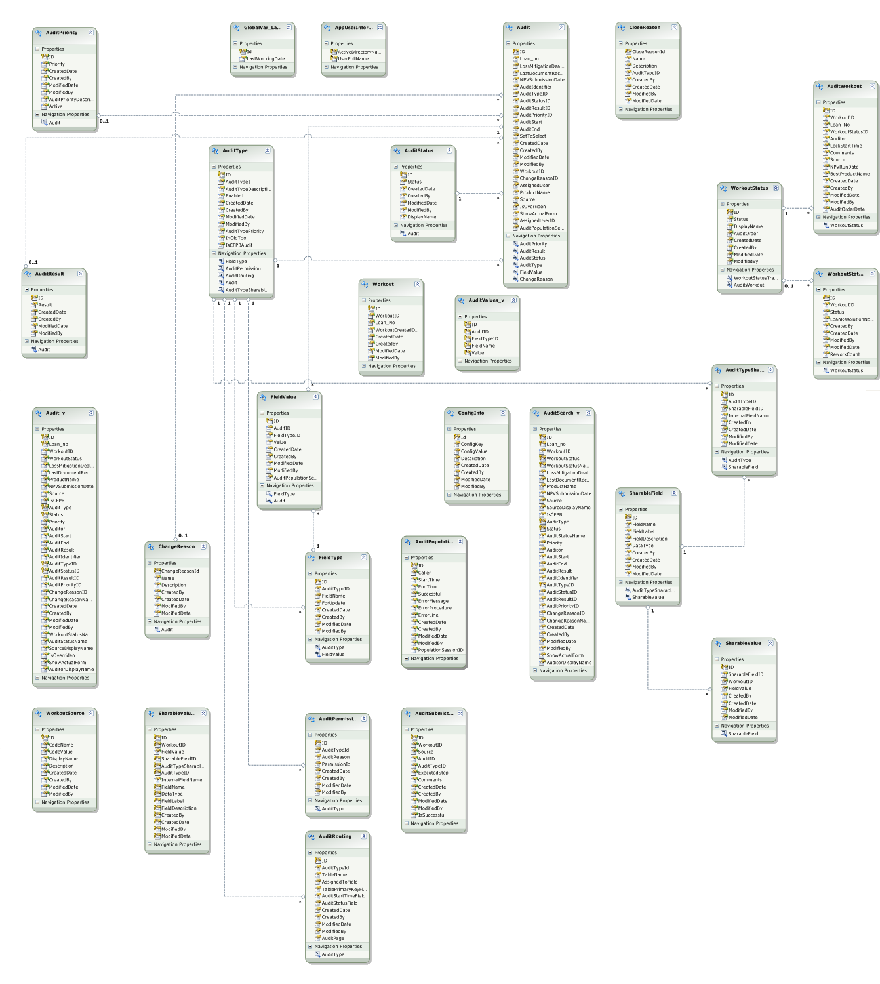

## Audience & Ownership

|  |  |  |
| --- | --- | --- |
| Target Audience | *Who are the primary users of the system for which the functionality should be targeted?* | * IT/Service Desk |
| Administrators | *Who is responsible for configuring the system and ensuring its availability?* |  |
| Technical Owners | *IT team responsible for supporting the system.* |  |
| Technical SMEs | *IT associates most familiar with the system. They are responsible for guiding the technical direction of the system.* |  |
| Business Owners | *Business associates responsible for the functionality of the system. They must approve any change to the system before development begins.* | * IT/Service Desk |
| Stakeholders | *Leaders of departments who may be impacted by system changes. This typically includes the business units who use the system, as well as training and Analytics. The stakeholders will need to approve the changes before deployment, as well as the timing of the changes.* |  |
| Vendor Contacts | *Support information for vendors associated with this system.* | * N/A |

## Installation

System: Windows XP / Windows 7

Environment: IIS

Installation:

## System Requirements

This section includes all of the requirements and dependencies needed for the system to run.

|  |  |  |
| --- | --- | --- |
|  | Requirements | Details |
| Web Server | * IIS | N/A |
| App Server | * N/A | N/A |
| Citrix | * N/A | N/A |
| Desktop | * N/A | N/A |
| File Locations | * N/A | N/A |
| Dependencies | * N/A | N/A |
| MoveIT | * N/A | N/A |

## Database Connectivity

This section describes the methods used for accessing data from the database.

|  |  |  |  |
| --- | --- | --- | --- |
| Server | Database | Authentication | How Used |
| SLSQLDEV01\DEV_2005  SLSQLTEST01\TEST_2005  SLSQLRC2  SLSQLRC2\STATIC  SLLTS | ApplicationManagement | Integrated | connectionStrings.config |
| SLSQLDEV01\DEV_2005  SLSQLTEST01\TEST_2005  SLSQLRC2  SLSQLRC2\STATIC  SLLTS | DefaultAdministration | Integrated | App.Config |

## Security

This section describes the security needs and features of the system.

### System Security

|  |  |  |
| --- | --- | --- |
| Security Type | Security Process | Administered By |
| DB | AD Integrated | DBA |

### Security Objects

|  |  |  |  |
| --- | --- | --- | --- |
| name | Type | Description | How Used |
| N/A | N/A | N/A | N/A |

## TFS Path

**TFS2010:** $/Dev/QC Audit Tool/QC Audit MVC_DevTrack2.1.2

## Version History

|  |  |  |  |
| --- | --- | --- | --- |
| Version | Date | Author | Modification |
| 1.0 | 03/26/2014 | BirneyWang | Initial Creation |
|  |  |  |  |
|  |  |  |  |